# CHAPTER 1

## PREFACE:

In a world where mobility is synonymous with progress, road safety stands as a fundamental pillar of civilization. Every journey embarked upon, whether a short commute or a long-haul expedition, carries with it inherent risks. With the advancements in vehicular technology, the evolution of driving norms, and the ever-expanding network of roads, the need for a comprehensive understanding of road safety has never been more paramount. This report delves into the multifaceted realm of road safety, focusing particularly on the nuances of driving practices, the challenges posed by night driving, and the critical maneuvers involved in emergency braking.

Driving, once considered a skill, has transformed into a daily routine for millions worldwide. However, beneath the seemingly routine act lies a complex interplay of decisions, reactions, and environmental factors. From mastering the art of defensive driving to navigating through congested urban centers, drivers encounter a myriad of situations demanding their utmost attention and expertise. This section of the report aims to dissect the various facets of driving, shedding light on effective strategies, common pitfalls, and the role of technology in enhancing driver safety.

The cloak of darkness brings forth a unique set of challenges for drivers, amplifying the risks inherent in road travel. Reduced visibility, impaired depth perception, and increased likelihood of encountering fatigued or intoxicated drivers pose significant threats to night-time commuters. Despite the advent of advanced lighting systems and driver assistance technologies, night driving remains a formidable task that demands heightened vigilance and adherence to safety protocols. Through a comprehensive analysis of the factors influencing night-time road safety, this report endeavors to equip drivers with the knowledge and tools necessary to navigate the nocturnal landscape securely.

By understanding these road safety challenges and learning practical strategies to address them, drivers can significantly improve their ability to navigate nighttime roads with confidence. This report equips readers with the knowledge and skills to manage headlight glare, execute emergency braking maneuvers effectively, and ultimately, arrive at their destinations safely.

## MOTIVATION:

Nighttime driving poses a considerable risk to road safety, primarily due to the limitations of traditional headlight systems and the challenges they present to drivers. The prevalence of accidents during nighttime hours underscores the urgent need for innovative solutions to mitigate these risks. The blinding glare from oncoming vehicles, exacerbated by the widespread use of high beams on highways, further compounds these challenges, creating a hazardous environment for all road users. Addressing these issues is crucial not only for enhancing the safety of nighttime driving but also for reducing the overall incidence of accidents on our roads.

By focusing on the development and evaluation of advanced automotive safety technologies, such as Adaptive Headlight Systems [AHS] and Emergency Brake Alert System [EBAS]. These technologies offer promising avenues for improving visibility, enhancing communication between vehicles, and empowering drivers to respond effectively to potential hazards on the road. By leveraging these innovations, we can mitigate the risk of rear-end collisions, which are often attributed to driver inattention or delayed reactions, thus fostering a safer driving environment for all.

Ultimately, the rationale for this project lies in its potential to save lives, prevent injuries, and reduce the economic and social costs associated with nighttime driving accidents. By shedding light on the effectiveness of innovative safety technologies and providing evidence-based recommendations for their implementation, we aim to contribute to the ongoing efforts to improve road safety and enhance the quality of life for drivers and passengers alike.

For our project, we visited the car showroom to inspect the safety features of various car models and identify safety issues such as high glare and emergency brake collision accidents. During our visit, we physically examined the glare problems by observing real cars and interacting with their safety systems. Additionally, we consulted with experts and studied research papers to understand the current challenges faced by drivers and passengers in terms of safety during transportation. There spoke with the seller there and gathered the following list of issues:

* Glare-related accidents caused by intense illumination from oncoming vehicles' headlights.
* Delayed reaction times during emergency braking situations, resulting in rear-end collisions.
* Lack of effective glare mitigation systems in vehicles, leading to impaired visibility and increased accident risks.
* Inadequate communication between vehicles regarding sudden braking events, contributing to accident severity.
* Absence of advanced braking assistance systems to aid drivers in responding to emergency situations promptly.

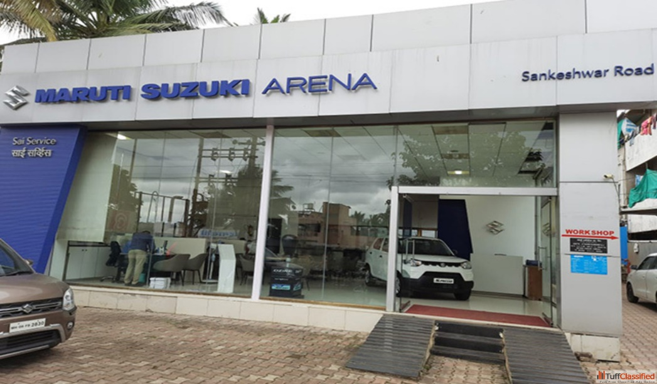At the showroom, we focused on evaluating the effectiveness of safety technologies and assessing their relevance to real-world driving scenarios. By examining the latest advancements in automotive safety, including collision avoidance systems, adaptive headlights, and emergency braking systems, we aimed to gain insights into their potential to address common safety concerns on the road.

**Fig. 1.2.1. Maruti Suzuki Showroom Gadhinglaj**

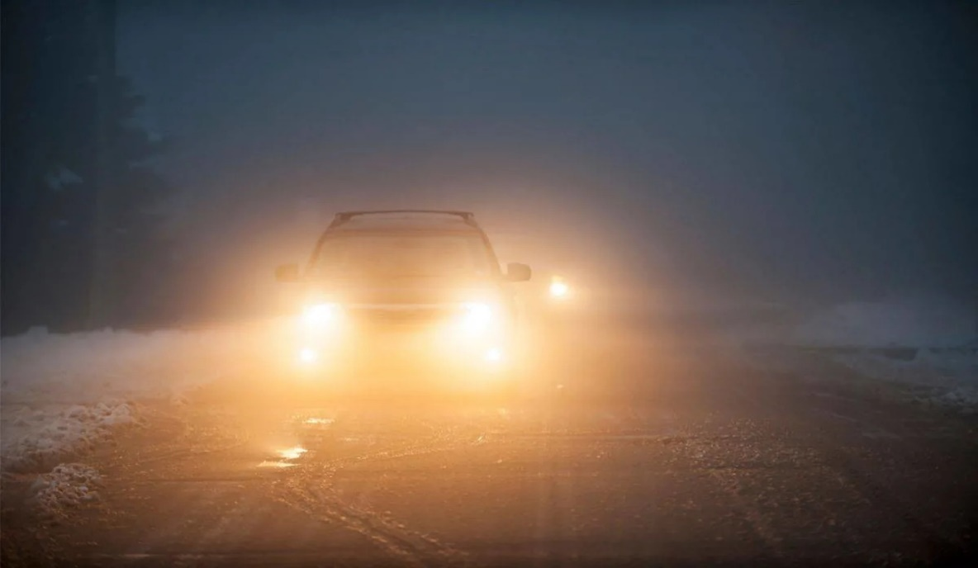So, after gathering all of the issues with the most recent technology that they are using, after reading the research papers to find solutions to the current issues that the globe is currently experiencing.

**Fig. 1.2.2. Glare From Front Vehicle.**

By integrating a range of sensors and advanced technologies, our proposed system aims to address the challenges posed by high glare and emergency brake situations. Through the implementation of innovative solutions, the system will be capable of monitoring glare levels and ensuring that headlights are adjusted to minimize glare for oncoming drivers, thus enhancing overall visibility and reducing the risk of accidents caused by glare-related distractions.

Additionally, our system will incorporate sensors to detect emergency braking events promptly. Upon detection, the system will send instant notifications to surrounding vehicles and relevant authorities, enabling swift responses to mitigate the risk of rear-end collisions and minimize the potential for injury or loss of life. By facilitating rapid communication and alerting drivers to potential hazards, our solution aims to significantly enhance road safety during emergency braking scenarios.

## ORGANIZATION OF REPORT:

The Introduction and Motivation behind the project were covered in the first chapter. Project literature review covered in the second chapter in this, different articles pertinent to the project and evaluated the need for it. The introduction and the problem statement with its general implementation such as block diagram, circuit diagram is included in the third chapter. Additionally, the details on how the project's operational process works, and the system created along with the information related to the components used in the system are discussed in the fourth chapter. In the fifth chapter, it includes the results or the outcomes of the implemented system design and future scope of the system as well as advantages and disadvantages of implemented system. At last, the sixth chapter gives the concluded part of the system. It includes the overall conclusion received by the results of the implemented system.

**Summary –** The first chapter gives the brief information related to project preface, motivation behind project and organization of report.

# CHAPTER 2 LITERATURE SURVEY

Literature survey is very important while defining the novel approach it helps to understand the extensive survey done by various authors reading the proposed topic and describe the methodology used with their pros and cons.

**Table (1): Literature Review**

|  |  |  |  |
| --- | --- | --- | --- |
| **Ref.** | **Author Name, Journal Name and Year of Publication** | **Findings** | **Drawbacks** |
| 1 | Linfeng Jia et al. ***“Design of a Smart Lighting System Based on Sensor Integration and***  ***Automation”*** | 1. The BH1750 sensor operates by converting light intensity into digital values, making it suitable for measuring ambient light levels accurately. 2. Integration of the BH1750 sensor with smart lighting systems enables automatic adjustment of LED light brightness according to ambient light conditions. | 1. Any inaccuracies or malfunctions in the sensor could lead to incorrect adjustments in LED brightness, impacting user experience and energy efficiency. |
| 2 | Jiang Li. ***“A Matrix Headlamp Design Based on Artificial Intelligence Controller Control”,*** Journal of Physics: Conference Series, ICCASIT 2020 | 1. Matrix headlights offer advantages over traditional LED headlights, providing a wider range of lighting and more precise illumination. 2. The use of AI-based controller control enables matrix headlights to automatically adjust brightness and lighting patterns according to environmental factors such as light intensity and human presence. | 1. Despite improvements in energy efficiency and lighting effectiveness, the practical application of the proposed matrix headlights has not fully met ideal expectations, with observed discrepancies in energy consumption, adjustment rates, and illumination levels compared to theoretical ideals. |
| 3 | Keshav H. Jatakar et al. ***“Vibration monitoring System based on ADXL335 accelerometer and arduino 2560 interface”,*** J*ournal* of Algebraic Statistics Volume 13, (2022) | 1. This article is based on Vibration monitoring system which is operated on ADX335 accelerometer and Arduino 2560 interface. 2. It gives the detail information related to accelerometer and vibrating motors. | 1. In this study mode of the group delay is increased with increased attenuation. 2. The position of accelerometer should be at an initial position to get accurate values. |
| 4 | Leo Louis, ***“Working principle of Arduino and using it as a tool for study and research”***  IJAER Volume-13, (2018) | 1. This paper explores the working principle and applications of an Arduino board. | 1. The paper shows that Arduino’s have limited memory and processing power. |
| **5** | Pallavi Polsani et al***. “Design & Verification of Serial Peripheral Interface (SPI) Protocol”***, International Journal of Recent Technology and Engineering (IJRTE) ISSN: 2277-3878 (Online), Volume-8 Issue-6, March 2020 | 1. The paper provides a comprehensive overview of the SPI protocol, including its architecture, signal descriptions, and data transmission modes. It emphasizes SPI's high-speed, full-duplex, and synchronous communication capabilities, making it suitable for microcontroller-peripheral communication. | 1. While the paper extensively covers the design, implementation, and verification aspects of SPI, it lacks detailed discussions on performance metrics such as throughput, latency, and scalability. These metrics are crucial for assessing the practical effectiveness of the SPI protocol in real-world applications. |

|  |  |  |  |
| --- | --- | --- | --- |
| 6 | Dr. Sagar Patelet al.  *“****Design of I2C Protocol”****,* International Journal of Technical Innovation in Modern Engineering & Science (IJTIMES) Volume 5, Issue 03, March-2019 | 1. The paper provides a comprehensive overview of the I2C protocol, highlighting its simplicity, bidirectional nature, and multi-master capability. 2. Various aspects of I2C protocol operation are explained, including the roles of SDA and SCL lines, addressing modes, and data transfer mechanisms. | 1. Comparative analysis with other communication protocols, particularly SPI, is missing, which could provide insights into relative strengths and weaknesses. |
| 7 | Kristian Ismail et al. ***“Design of CAN bus for research applications purpose hybrid electric vehicle using ARM microcontroller”,*** 2nd International Conference on Sustainable Energy Engineering and Application, ICSEEA 2014 | 1. The paper proposes a comprehensive solution for designing a CAN bus protocol for research applications in hybrid electric vehicles (HEVs) using an ARM microcontroller. It addresses the need for a multi-master communication protocol to replace centralized control systems. 2. The paper effectively utilizes the Controller Area Network (CAN) protocol, known for its multicast-based communication and deterministic resolution of contention, making it suitable for automotive applications. | 1. While the paper focuses on research applications in HEVs, it does not explore the potential challenges or adaptations required for real-world deployment in commercial vehicles or production environments. |
| 8 | H Shambhavi et al “***AUTOMIZING CAN COMMUNICATION SYSTEM USING RASPBERRY-PI***” International Research Journal of Modernization in Engineering Technology and Science Volume:04/Issue:09/September-2022 | 1. This is the core component responsible for implementing the CAN protocol. It handles tasks such as message arbitration, error detection, and message transmission/reception. | 1. The MCP2515 has a relatively small number of transmit and receive buffers compared to more advanced CAN controllers. This limitation can lead to issues in systems with high message throughput or complex communication requirements. |
| 9 | Dzulfiqar Dwi Yanto et al ***“Design of Automatic Headlight Based on Road Contour and Other Headlight Light”*** Conference: 2020 2nd International Conference on Industrial Electrical and Electronics (ICIEE) October 2020. | 1. This study uses the BH1750 module as the main component to detect other vehicles facing in front of it. 2. This study also used the MPU6050 module to assess road contours. | 1. In laboratory testing, the MPU6050 module as an accelerometer, the BH1750 module as a lux meter, MG995 Servo Motor movement testing and overall tool testing is tested. |
| 10 | Arpita K et al ***“Automated Headlight Intensity Control and Obstacle Alerting System”*** ternational Journal of Engineering Research & Technology (IJERT) ISSN: 2278-0181 Published by, www.ijert.org NCESC - 2018 Conference Proceedings Special Issue – 2018. | 1. This paper is aimed to design and perform a smart vehicle headlights control system to adjust vehicle headlights automatically according to the surrounding lighting condition. 2. The system device automatically switches the headlight to low beam when it senses a vehicle approaching from the opposite side using Light Dependent Resistor (LDR) sensor. | 1. Automatic headlight intensity beam is controlled by using photo transistor and XBee, which is not efficient for measure the intensity of light. |

|  |  |  |  |
| --- | --- | --- | --- |
| 11 | Surej Mouli et al ***“Investigating the Cognitive Response of Brake Lights in Initiating Braking Action Using EEG”*** IEEE TRANSACTIONS ON INTELLIGENT TRANSPORTATION SYSTEMS, VOL. 23, NO. 8, AUGUST 2022. | 1. This study investigated EEG analysis of brake lights based on conventional bulbs and newer LED designs. 2. P3 components were analyzed from channel Pz for 22 subjects with ten different brake light assemblies, and analyzed for statistical differences in terms of the latency of the cognitive component from the brake light onset. 3. This article was found that both the bulb-based lights evoked slower responses than all of the LED lights. |  |
| 12 | Mohammad Sadegh Sohrabi ***“Effects of Flashing Brake Lights on Drivers’ Brake Reaction Time and Releasing Accelerator Gas Pedal Time”*** Health in Emergencies and Disasters Quarterly. 2019. | 1. The flashing brake lights were used to decrease the driver’s brake reaction time and prevent the rear-end collisions. By using flashing brake lights with a frequency of 7 Hz, the brake reaction time decreased 323.42 ms. 2. The article found by increasing the age of the driver, a significant decrease in brake reaction time is observed (11.58 ms). |  |

**Summary –** The Second chapter gives the literature survey for the proposed implementation.

# CHAPTER 3 IMPLEMENTED PROJECT WORK

## INTRODUCTION:

The project aims to tackle road safety concerns by implementing innovative solutions targeting two key areas. The first initiative focuses on mitigating accidents caused by the blinding glare of upper lamps from oncoming vehicles. This glare often leads to impaired visibility, increasing the risk of accidents. To address this, an adaptive headlight system will be developed and integrated into vehicles. This system will utilize advanced sensors and image recognition technology to dynamically adjust the direction and intensity of the vehicle's headlights. By automatically responding to the presence of oncoming vehicles, pedestrians, and varying road conditions, the adaptive headlight system aims to reduce glare and improve visibility for both the driver and other road users.

By integrating advanced technology into vehicle safety systems, the project aims to provide proactive measures to mitigate the occurrence and severity of accidents. The adaptive headlight system's ability to dynamically adjust the headlights based on real-time environmental factors ensures optimal visibility in various driving conditions. This not only reduces the risk of accidents caused by glare but also enhances overall driving comfort and safety [13].

In parallel, the project addresses the need to minimize the risk of rear-end collisions through the implementation of Flashing Brake and Hazard Systems. These systems are designed to enhance communication between vehicles, thereby reducing reaction times and enhancing overall road safety. When the vehicle's sensors detect sudden deceleration, the Flashing Brake and Hazard Systems will activate, causing the vehicle's brake lights and hazard lights to flash rapidly. This visual alert will effectively inform following drivers of the abrupt stop or potential danger ahead, encouraging them to react promptly and safely.

Similarly, the Flashing Brake and Hazard Systems leverage sensor data to provide timely visual alerts to following drivers in the event of sudden deceleration. This proactive approach to communication between vehicles promotes safer driving practices and reduces the likelihood of rear-end collisions. Additionally, by increasing awareness and reaction time among drivers, these systems contribute to a safer road environment for all road users [14].

Moreover, the implementation of these safety features demonstrates a commitment to leveraging technology for the betterment of road safety. By addressing specific challenges such as glare from oncoming headlights and communication between vehicles during braking events, the project aims to make significant strides towards reducing accidents and improving overall road safety standards.

The AHS is a cutting-edge technology designed to address the issue of blinding glare from oncoming vehicle headlights, which can often lead to impaired visibility and increased accident risks. AHS utilizes advanced sensors and image recognition technology to dynamically adjust the direction and intensity of a vehicle's headlights in response to various environmental factors and driving conditions. By automatically detecting the presence of oncoming vehicles, pedestrians, and other road hazards, AHS aims to reduce glare and improve visibility for both the driver and other road users.

One of the key features of AHS is its ability to adaptively control the direction of the vehicle's headlights based on real-time data. This means that the headlights can adjust their angle and range to optimize visibility without causing discomfort or glare to other road users. By dynamically adjusting the headlights, AHS ensures that the driver has optimal visibility of the road ahead while minimizing the risk of blinding oncoming drivers.

Moreover, AHS is designed to enhance safety by providing proactive responses to changing road conditions. For example, the system can detect curves, bends, and obstacles in the road ahead and adjust the headlights accordingly to provide better illumination of the path. This proactive approach to lighting helps drivers anticipate and react to potential hazards more effectively, reducing the likelihood of accidents.

Another important aspect of AHS is its integration with other vehicle safety systems, such as collision avoidance and driver assistance systems. By sharing data and coordinating responses with these systems, AHS can provide a more comprehensive safety solution. For instance, AHS can work in conjunction with adaptive cruise control to adjust the headlights based on the distance and speed of surrounding vehicles, further enhancing safety on the road.

In addition to improving safety, AHS also offers benefits in terms of driving comfort and convenience. By automatically adjusting the headlights, the system relieves the driver of the need to manually control the lights, allowing them to focus more on the task of driving [15].

The EBAS is a vital safety feature designed to mitigate the risk of rear-end collisions by providing timely warnings to following drivers when a vehicle abruptly decelerates. This system utilizes a combination of sensors, such as radar and cameras, to detect sudden decreases in speed indicative of emergency braking situations. Upon detecting such a scenario, the EBAS activates visual and auditory alerts within the vehicle, signaling to the driver the need for immediate attention and caution.

One of the key functions of the EBAS is its ability to rapidly alert following drivers of the sudden braking action of the vehicle ahead. This is achieved through the activation of high-intensity flashing brake lights and hazard lights, which serve as highly visible visual cues to alert following motorists of the potential danger ahead. By drawing attention to the abrupt deceleration, the EBAS aims to prompt following drivers to react quickly and adjust their driving behavior to avoid a collision [17].

In addition to providing immediate alerts to following drivers, the EBAS also plays a crucial role in enhancing communication and situational awareness on the road. By signaling the occurrence of an emergency braking event, the system helps create a shared understanding among road users, fostering safer driving practices and reducing the likelihood of rear-end collisions. Furthermore, the EBAS contributes to a culture of mutual respect and responsibility among drivers, promoting a collective commitment to road safety.

## PROBLEM STATEMENT:

In the realm of automotive safety and visibility, a pressing need exists for an innovative solution to enhance driver safety during nighttime driving and sudden braking situations. Traditional headlights lack adaptability, potentially resulting in reduced visibility and accidents. Moreover, the absence of a standardized emergency brake signaling method is a significant road safety concern. This project aims to tackle these issues by developing an adaptive headlight system that dynamically adjusts headlight angles based on road conditions and integrating an emergency brake light flash feature. The primary objective is to improve road safety, reduce accidents, and enhance communication between drivers and other road users during emergencies. This cost-effective solution is intended for broad vehicle integration, promoting overall road safety and driver comfort.

## BLOCK DIAGRAM OF SYSTEM:

The system consists 4 different subblocks. It consists of following block:

* + 1. Control Unit
    2. Main Control Unit (MCU)
    3. Front Section
    4. Back Section

The components of the system are as following:

1. Arduino UNO module
2. Arduino NANO module
3. BH1750 - Light Intensity Sensor Module
4. ADXL335 module
5. CS100 Ultrasonic Distance Measuring Sensor Module
6. MCP2515 CAN Bus Module with TJA1050 Trans Receiver
7. TA6586 Based Motor Driver Module
8. NRF24L01 2.4GHz PA+LNA SMA Wireless Transceiver Module with Antenna
9. Dual Axis XY Joystick Module
10. Matrix LED Headlight

## Steps:

## Control Unit

1. In Fig.3.4.1.1 the main component of the system for remote control with NRF24 is the Microcontroller, specifically the Arduino Nano. It serves as the central processing unit to manage and coordinate the connected devices.
2. The system incorporates three joysticks and a dual side switch for remote control functionality. These input devices are interconnected and linked to the Arduino Nano for transmitting control signals wirelessly via NRF24 communication modules.
3. A battery is integrated into the system to power the Arduino Nano and other connected components, ensuring portability and flexibility in usage.
4. The NRF24 modules facilitate wireless communication between the remote-control unit and the main system. They enable the transmission of control signals from the joysticks and switches to the Arduino Nano.

Switch

Arduino Nano

Battery

NRF24

**Fig. 3.4.1. Block Diagram of Control Unit**

## MCU

1. The NRF24 modules facilitate wireless communication between the remote-control unit and the main system. They enable the transmission of control signals from the joysticks and switches to the Arduino Uno for processing.
2. The ADXL335 module is utilized for angle detection within the system. It interfaces with the Arduino Uno to convert the incoming analog signals from sensors into digital data for angle measurement.
3. The TA6586 Based Motor Driver Module is employed to control the DC motor responsible for driving the car. It receives control signals from the Arduino Uno and regulates the motor's speed and direction accordingly.
4. The MCP2515 CAN Bus Module with TJA1050 Trans Receiver is integrated into the system for CAN protocol communication. It enables communication between different components of the system using the CAN protocol, allowing for efficient data exchange and coordination.

ADXL335

MCP2515

NRF24

Arduino UNO

Battery

Motor Driver Module

**Fig. 3.4.2. Block Diagram of MCU**

## Front Section

1. The BH1750 Light Intensity Sensor Module is employed for sensing light intensity levels. It interfaces with the Arduino Nano, providing real-time data on ambient light conditions within the environment.
2. The Ultrasonic Distance Measuring Sensor plays a crucial role in detecting upcoming vehicles. It connects to the Arduino Nano and provides data on distances, enabling the system to detect vehicles approaching the car.
3. The Relay Module is utilized for controlling the LED headlights, including both standard and matrix LED configurations. It interfaces with the Arduino Nano, allowing for precise control over the lighting system based on various conditions.
4. Additionally, the MCP2515 CAN Bus Module with TJA1050 Trans Receiver is employed for CAN communication, enabling seamless data exchange and coordination between different components of the system.

Matrix Led Headlight

Matrix Led Headlight

Relay Module

MCP2515

Battery

Arduino NANO

BH1750

Ultrasonic Sensor

**Fig. 3.4.3. Block Diagram of Front Section**

## Back Section

1. The Arduino Nano serves as the central controller for the back section of the system. It coordinates the functionalities of various components and processes incoming data to ensure smooth operation.
2. The MCP2515 CAN Bus Module with TJA1050 Trans Receiver is integrated into the system to facilitate CAN communication. This module enables seamless data exchange and coordination between different components of the back section, ensuring efficient communication within the system.
3. LED backlighting for the car is controlled by the Arduino Nano through a relay module. This setup allows for precise control over the backlighting, enhancing visibility and safety during nighttime driving.
4. Additionally, a relay module is utilized for controlling the backlighting. The Arduino Nano interfaces with this module to regulate the backlighting as per the specified requirements, ensuring optimal illumination for the vehicle's rear section.

Indicater

Backlight

Relay Module

Arduino NANO

MCP2515

Battery

**Fig. 3.4.4. Block Diagram of Back Section**

## CIRCUIT DIAGRAM OF SYSTEM:

Indeed, the system architecture involves four distinct blocks, each equipped with its own controller, and they communicate via the MCP2515 CAN communication protocol. Additionally, the entire car is managed via a remote controller, facilitated by the NRF24 modules. This setup ensures efficient coordination and control throughout the vehicle's operation, enabling seamless communication and interaction between different components and functionalities.

As first section is the remote control unit. The remote control unit's core is the Arduino Nano, serving as the central controller. It efficiently manages input signals from three joysticks and a dual side switch, seamlessly interfacing with them to transmit control signals wirelessly via NRF24 modules. Powered by a compact battery, the Nano ensures portability and flexibility in usage. Additionally, the NRF24 modules play a vital role in facilitating wireless communication between the remote unit and the main system, completing a cohesive setup for remote control operations.

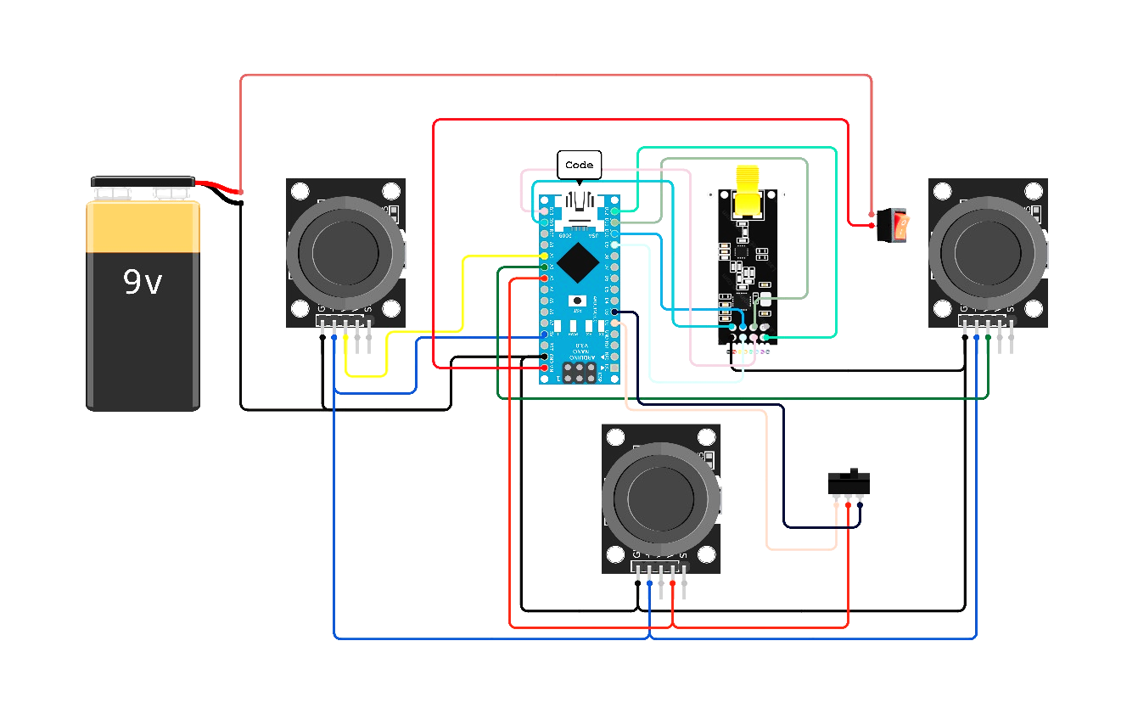

**Fig.3.5.1. Circuit Diagram of Remote controller**

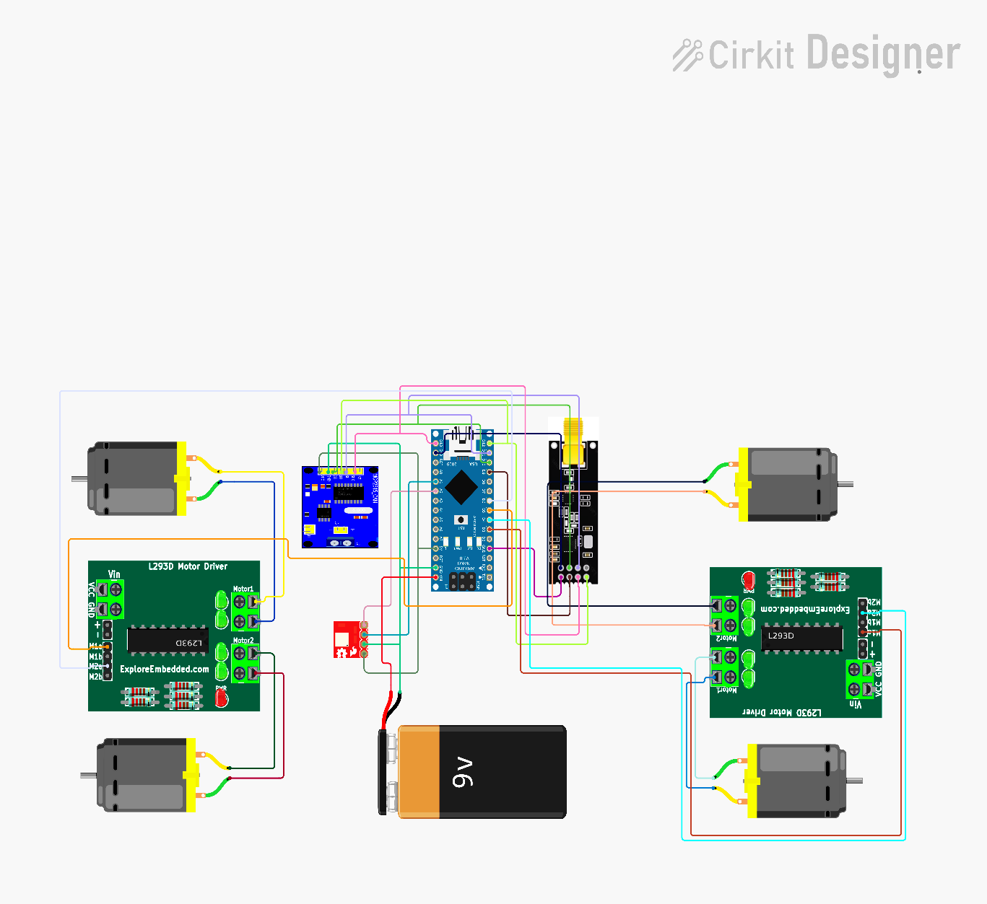The MCU section comprises essential components for system functionality. NRF24 modules facilitate wireless communication between the remote control and main system, transmitting control signals from joysticks and switches to the Arduino Uno. The ADXL335 module detects angles, interfacing with Uno to convert analog signals into digital data. A TA6586-based Motor Driver controls the car's DC motor, receiving signals from Uno for speed and direction regulation. Integration of MCP2515 CAN Bus Module with TJA1050 Trans Receiver enables CAN protocol communication, fostering efficient data exchange and coordination among system components.

**Fig.3.5.2. Circuit Diagram of MCU**

The front section features essential components for enhanced vehicle functionality. The BH1750 Light Intensity Sensor Module interfaces with the Arduino Nano to provide real-time data on ambient light conditions. Complementing this, the Ultrasonic Distance Measuring Sensor connects to the Nano, enabling accurate detection of nearby vehicles. Control over the LED headlights, encompassing standard and matrix configurations, is facilitated by the Relay Module, ensuring precise illumination under varying conditions. Additionally, seamless data exchange and coordination are achieved through the MCP2515 CAN Bus Module with TJA1050 Trans Receiver, enhancing system integration and functionality.

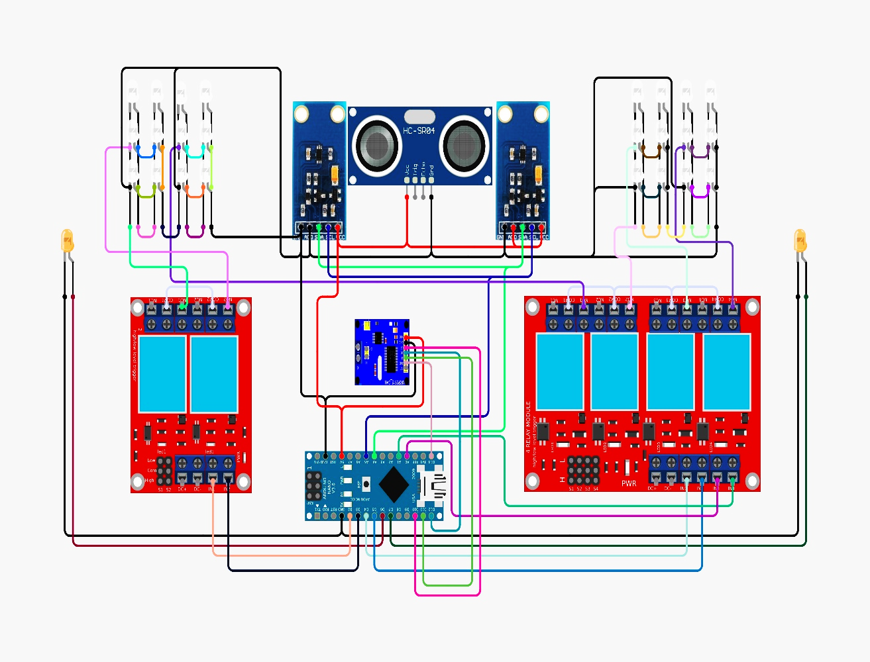

**Fig.3.5.3. Circuit Diagram of Front Section**

In the back section, the Arduino Nano assumes the role of the central controller, orchestrating the functionalities of various components to ensure seamless operation. Integrated into the system, the MCP2515 CAN Bus Module with TJA1050 Trans Receiver facilitates CAN communication, enabling efficient data exchange and coordination among different back section components. The Nano also governs LED backlighting via a relay module, providing precise control for enhanced visibility and safety during nighttime driving. Additionally, another relay module interfaces with the Nano to regulate backlighting according to specific requirements, ensuring optimal illumination for the vehicle's rear section.

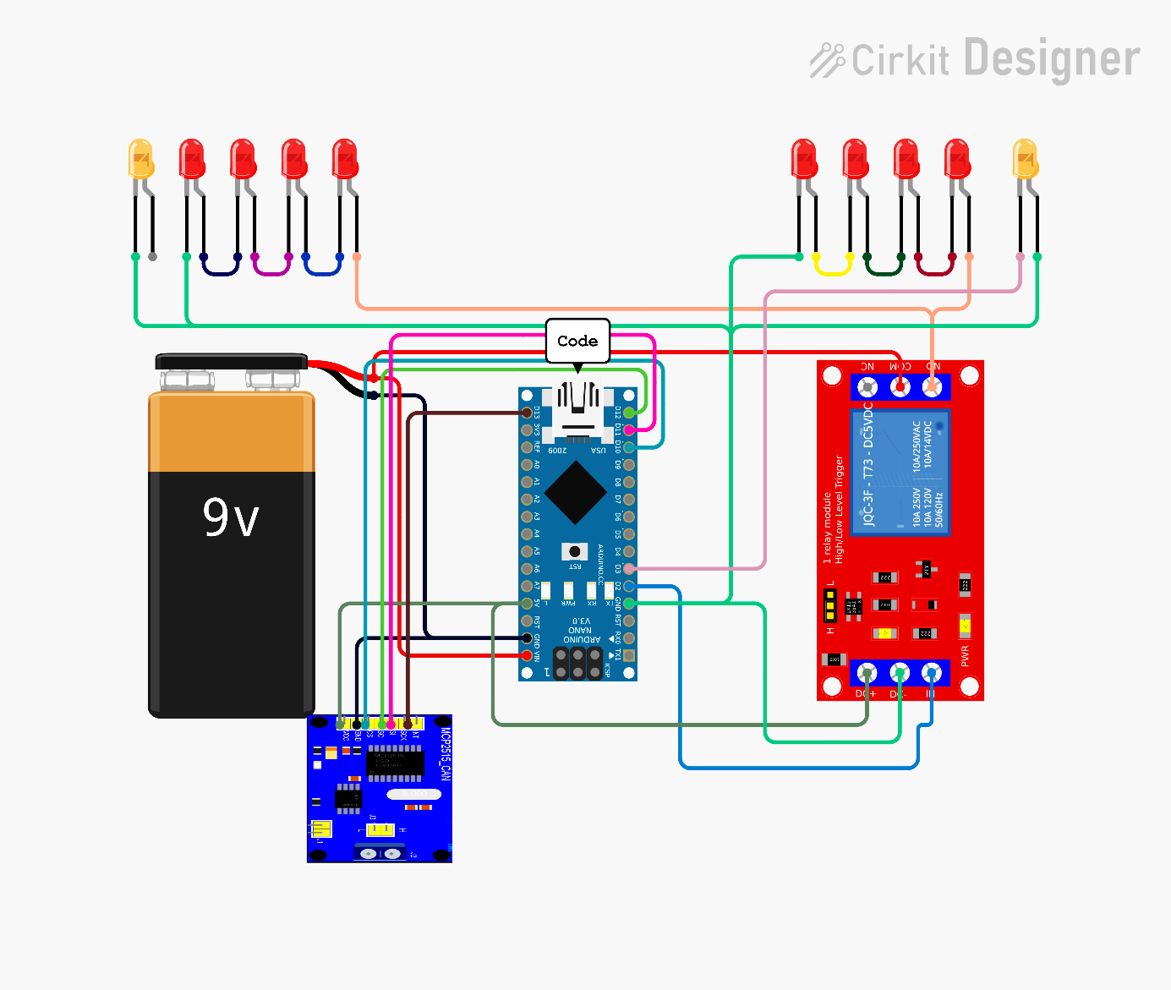

**Fig.3.5.4. Circuit Diagram of Back Section**

**Summary –**The Third chapter gives the information about the introduction, problem statement, block diagram and circuit diagram of the implemented system.

# CHAPTER 4 HARDWARE IMPLEMENTATION

A system consists of both hardware and software parts. This chapter include information of hardware implementation of the project.

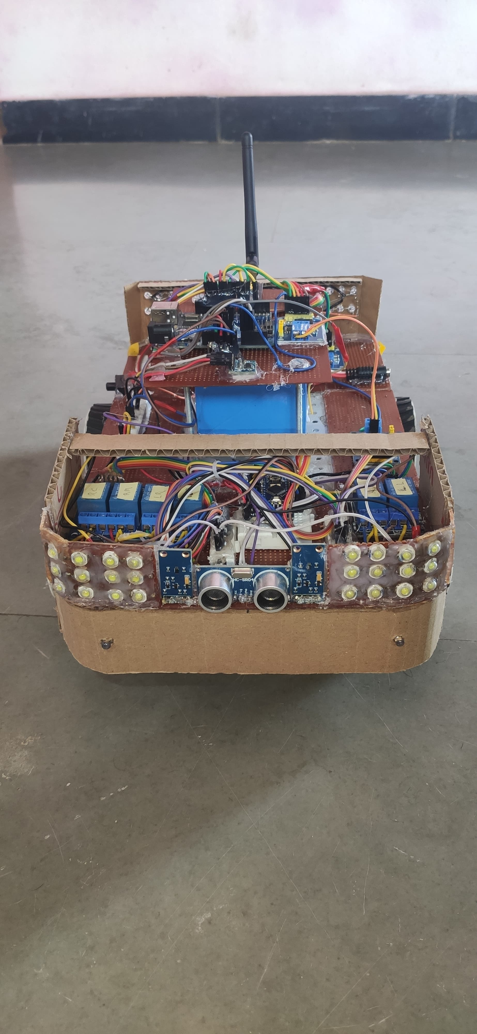

**Fig.4. Implemented Design**

## Implemented Design of system:

The Fig.4.1 shows how the components are mounted on Printed Circuit Board [PCB] board with the connecting wires. It shows that the PCB board is mounted on the car which includes the components such as Arduino UNO, Arduino NANO, Light Intensity Sensor Module, ADXL335 module, Ultrasonic Distance Measuring Sensor Module, MCP2515 CAN Bus Module with TJA1050 Trans Receiver, TA6586 Based Motor Driver Module, NRF24L01 and Matrix LED Headlight.

The whole Implemented structure is made up of iron plate and PCB plates. The following section gives details of the different Hardware components which includes following components:

## ARDUINO UNO

* 1. **Arduino UNO:**

Arduino UNO is a micro-controller board based on the ATmega328P chip. Arduino UNO acts as the brain of the system. It is used to control all the devices with the help of outputs received by them. It is one of the most popular boards in the Arduino family due to its simplicity, ease of use, and versatility. The board has 14 digital input/output pins, six analog inputs, a 16 MHz quartz crystal, a USB connection, and a power jack.

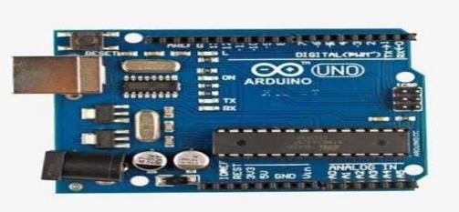

**Fig.4.1. Arduino UNO**

The digital pins can be configured as inputs or outputs and can be used for tasks such as controlling LED's, motors, or other electronic devices. The analog inputs allow the board to read analog signals from sensors or other devices. The USB connection is used to program the board and to communicate with it from a computer. The Arduino Uno board can be programmed using the Arduino programming language, which is a simplified version of C++ and is easy to learn. There are many libraries and examples available to help users get started with the board and to create projects quickly and easily. Overall, the Arduino UNO board is an excellent choice for beginners and experienced users alike who want to experiment with electronics and create their own projects [6]**.**

In this system, the Arduino Uno serves as the central processing unit for the car, controlling all connected peripherals and acting as the master node for CAN communication. Utilizing its digital and analog I/O pins, the Uno manages sensors, actuators, and other devices within the vehicle. While lacking built-in CAN hardware, external modules enable communication with other CAN-enabled components.

## Arduino Nano:

The Arduino Nano is a compact and versatile microcontroller board based on the ATmega328P chip, offering similar functionalities to the Arduino Uno but in a smaller form factor. With its small size and wide range of digital and analog I/O pins, the Nano is suitable for projects with space constraints or where portability is a priority. It features onboard USB connectivity for easy programming and power supply, making it convenient for rapid prototyping and deployment. Despite its compact size, the Nano retains compatibility with a vast ecosystem of Arduino libraries and shields, enabling developers to leverage existing resources for their projects. Its affordability and ease of use make it a popular choice for hobbyists, educators, and professionals alike, across various applications including robotics, IoT, and embedded systems. [18].

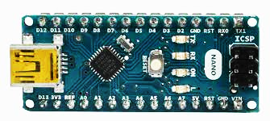

**Fig.4.2. Arduino NANO**

In this system, the Arduino Nano is deployed across three key sections of the car, each serving distinct functions to enhance functionality and safety. Firstly, acting as the central processing unit of the remote controller, the Nano facilitates wireless control of the car's movement, enabling users to maneuver the vehicle with ease and precision.

Moving to the front section of the car, the Arduino Nano takes on the responsibility of controlling the LED matrix headlight while also monitoring ambient light intensity using a sensor.

In the back section of the car, the Arduino Nano manages the backlighting system, illuminating the rear of the vehicle for enhanced visibility to following traffic. By controlling the intensity and timing of the backlighting.

## Light Intensity Sensor Module:

The BH1750 is a digital light sensor that provides accurate measurements of ambient light intensity. It communicates with microcontrollers via I2C interface, making it easy to integrate into various projects. Its small size and low power consumption make it suitable for applications such as automatic lighting control, backlight dimming for displays, and smart home automation. With its wide measurement range and high resolution, the BH1750 offers precise readings in both indoor and outdoor environments, making it a versatile choice for projects requiring light sensing capabilities [1].

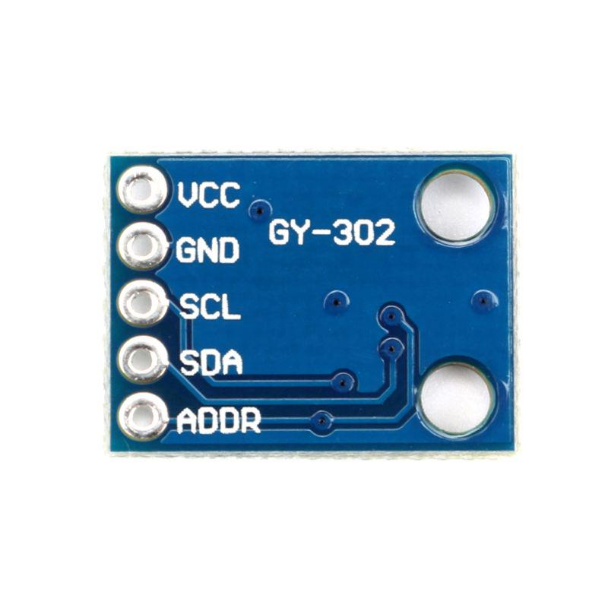

**Fig.4.3. Light Intensity Sensor Module**

In our system, the BH1750 sensor is employed to detect the light intensity of oncoming vehicles. Positioned strategically within the car's front section, the BH1750 provides real-time measurements of ambient light levels. By monitoring changes in light intensity, it enables the vehicle's control system to adjust its own lighting parameters accordingly, enhancing visibility and safety on the road. This data-driven approach allows for dynamic adaptation to varying driving conditions, ensuring optimal illumination while minimizing glare for other motorists.

## Ultrasonic Level Sensor Module:

## 

The Ultrasonic Level Sensor Module is a common choice for distance measurement in various applications due to its accuracy and reliability. It operates by emitting ultrasonic waves and measuring the time it takes for these waves to bounce back after hitting an object. This time measurement is then converted into distance using the speed of sound in air. With its simple operation and precise distance sensing capabilities, the Ultrasonic Level Sensor Module is ideal for detecting nearby objects or obstacles, making it a valuable component in automotive safety systems, industrial automation, and robotics [19].

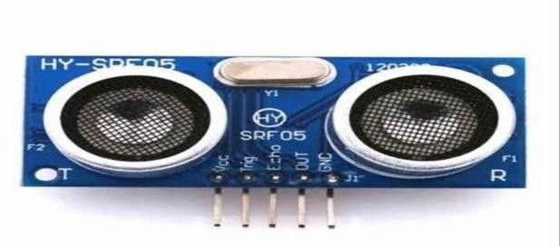

**Fig.4.4. Ultrasonic Level Sensor Module**

In our system, the Ultrasonic Level Sensor Module is specifically utilized to detect vehicles in the front of the car. Installed at the front bumper or grille, the sensor continuously emits ultrasonic pulses forward and analyzes the echoes to determine the distance to the nearest vehicle ahead. This information is crucial for implementing advanced driver assistance systems (ADAS) such as adaptive cruise control, collision avoidance, or automatic braking. By accurately sensing the proximity of front vehicles in real-time, our system enhances safety on the road by providing timely warnings to the driver or autonomously adjusting the car's speed to maintain a safe distance from other vehicles.

* 1. **ADXL335 Module:** (Accelerometer/Gyroscope)

It measures acceleration in three dimensions, enabling applications such as tilt sensing, motion detection, and vibration monitoring. The ADXL335 module consists of a MEMS (microelectromechanical system) sensor that detects acceleration along the X, Y, and Z axes, and an analog signal conditioning circuit that amplifies and filters the sensor output. The module typically includes a voltage regulator and a decoupling capacitor to provide stable power to the sensor and reduce noise.

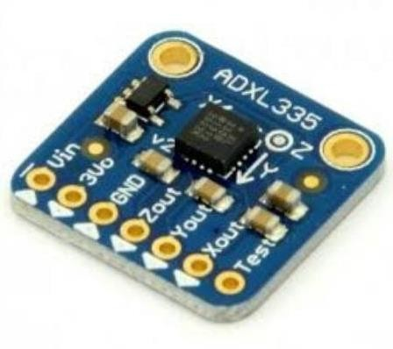

**Fig.4.5. ADXL335 Module**

In our system, the ADXL335 Module serves as a key component for detecting tilt and orientation changes in the car. The ADXL335 is a three-axis accelerometer sensor capable of measuring acceleration in the X, Y, and Z directions. By analyzing the acceleration data provided by the sensor, our system can determine the tilt angle and orientation of the vehicle with respect to the ground.

This information is valuable for implementing stability control systems, rollover detection, and other safety features in the car. Whether it's detecting sudden changes in vehicle orientation during cornering or alerting the driver of potential rollover situations, the ADXL335 Module plays a crucial role in enhancing the safety and stability of the vehicle.

## NRF24L01:

The NRF24L01 is a versatile and low-cost wireless transceiver module commonly used for communication between microcontroller-based devices. Operating in the 2.4GHz ISM band, it provides robust and efficient data transmission over short distances, making it suitable for applications such as remote control, sensor networks, and IoT devices. The NRF24L01 features a range of configurable parameters, including data rate, frequency channel, and power level, allowing for optimization based on specific project requirements. With its simple interface and support for point-to-point and multi-node communication topologies, the NRF24L01 is widely utilized in various projects requiring reliable wireless connectivity [20].

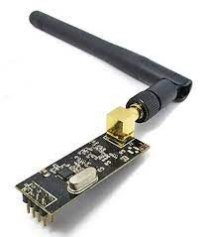

**Fig.4.6. NRF24L01**

In our system, the NRF24L01 module is utilized as the primary means of wireless communication for controlling the car via remote. Positioned within the remote controller, the NRF24L01 establishes a reliable communication link with a corresponding NRF24L01 module installed in the car's control unit. Through this wireless connection, commands from the remote controller, such as steering, acceleration, and braking, are transmitted to the car's control unit in real-time. The NRF24L01's low latency, robust communication protocol, and configurable settings make it well-suited for this application, ensuring responsive and accurate control of the car from a distance. This setup enhances user convenience and enables safe and efficient operation of the vehicle remotely.

## MCP2515 CAN Bus Module

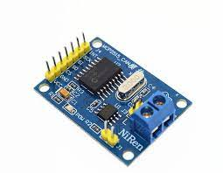The MCP2515 CAN Bus Module is a widely used CAN controller with SPI interface. It facilitates communication between microcontrollers and CAN bus networks, making it ideal for automotive applications, industrial automation, and IoT devices. The module integrates the MCP2515 CAN controller chip along with a transceiver, enabling seamless interfacing with CAN networks. With its flexible configuration options and high-speed operation, the MCP2515 module supports standard (11-bit) and extended (29-bit) message formats, as well as various baud rates. This versatility makes it suitable for a wide range of CAN-based projects, including vehicle diagnostics, data logging, and remote monitoring systems [8].

**Fig.4.7. MCP2515 CAN Bus Module**

In our system, the MCP2515 CAN Bus Module serves as the backbone for communication among all peripherals within the vehicle. Positioned as the central hub, the MCP2515 facilitates seamless data exchange between various components, including sensors, actuators, and control units. By utilizing the Controller Area Network (CAN) protocol, the MCP2515 ensures reliable and efficient communication even in noisy automotive environments. This setup enables different parts of the vehicle to exchange information, coordinate actions, and respond to dynamic conditions in real-time. Whether it's transmitting sensor data to the main control unit or coordinating the operation of different subsystems, the MCP2515 plays a crucial role in enhancing connectivity and functionality throughout the vehicle.

## Matrix LED Headlight

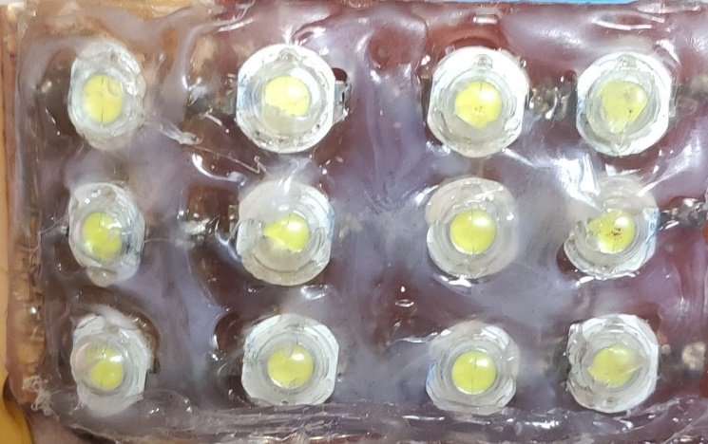Matrix LED headlights are advanced lighting systems that utilize an array of individual LED elements to provide adaptive and customizable illumination patterns. Unlike traditional headlights, which typically consist of a single light source, matrix LED headlights can dynamically adjust the light distribution to suit various driving conditions and scenarios. By selectively activating or dimming specific LED segments, matrix LED headlights can achieve functions such as adaptive high beam assist, glare-free high beam, and cornering lights. These headlights enhance visibility for the driver while minimizing glare for other road users, improving overall safety and comfort during nighttime driving. Matrix LED headlights are becoming increasingly popular in modern vehicles due to their superior performance, energy efficiency, and versatility [2].

**Fig.4.8. Matrix LED Headlight**

In our system, Matrix LED headlights are integrated into the vehicle's lighting system to provide advanced illumination capabilities. Positioned at the front section of the car, these headlights utilize an array of individual LED elements controlled by microcontrollers to dynamically adjust the light distribution based on driving conditions. By employing techniques such as adaptive high beam assist and glare reduction, Matrix LED headlights enhance visibility for the driver while ensuring safety for other road users. Additionally, these headlights may incorporate features such as cornering lights to improve visibility during turns. Through their advanced functionality and precise control, Matrix LED headlights elevate the driving experience, enhancing both safety and comfort on the road.

## Motor Driver Module

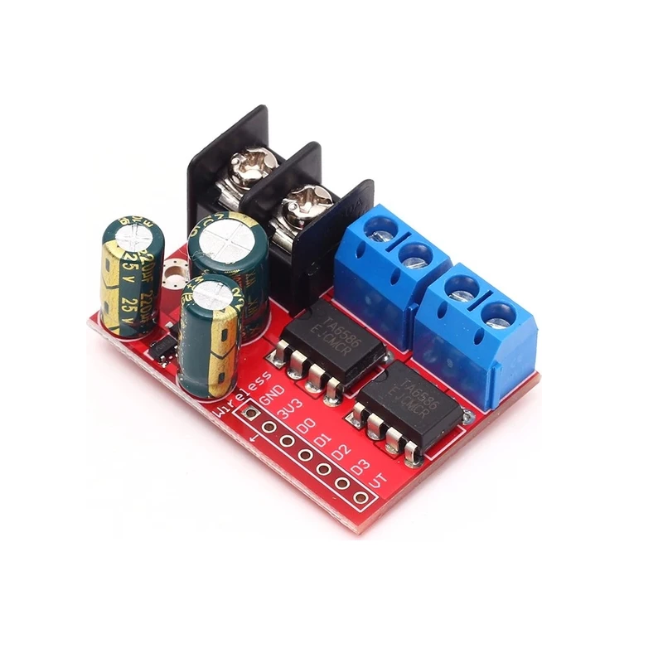The TA6586-based motor driver module is a compact and efficient solution for controlling DC motors in various applications. The TA6586 chip integrated into the module provides dual H-bridge motor control, allowing bidirectional control of two DC motors or a single stepper motor. With its built-in protection features such as overcurrent and thermal shutdown, the module ensures safe and reliable operation of the connected motors. Additionally, it offers PWM (Pulse Width Modulation) control for precise speed regulation and direction control. The module's compact size and easy interface make it suitable for a wide range of projects, including robotics, automation, and motorized vehicles, where precise motor control is essential.

**Fig.4.9. Motor Driver Module**

In our system, we utilize the TA6586-based motor driver module to drive the DC motors that propel the car. By connecting the module to the vehicle's DC motors, we enable precise control over their speed and direction, essential for maneuvering the car effectively. The module's dual H-bridge configuration allows bidirectional control, enabling forward and reverse motion as well as speed regulation through PWM signals. Additionally, the module's built-in protection mechanisms ensure the safe operation of the motors by preventing damage from overcurrent or overheating. Overall, the TA6586-based motor driver module serves as a reliable and efficient solution for powering and controlling the DC motors that drive our car.

**Summary –** The Fourth chapter gives all the detailed information related to hardware components used in this system.

# CHAPTER 5 SOFTWARE IMPLEMENTATION

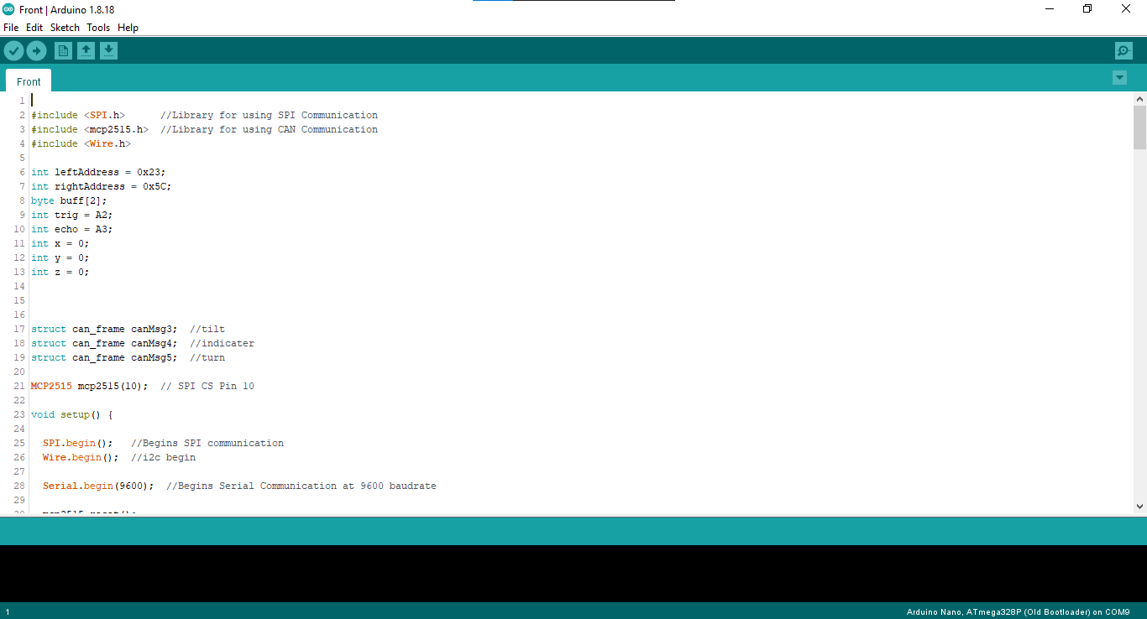The software implementation starts with the programming in Embedded C using Arduino IDE software tool. The below Figures shows the Example of software program implemented in Arduino IDE tool.

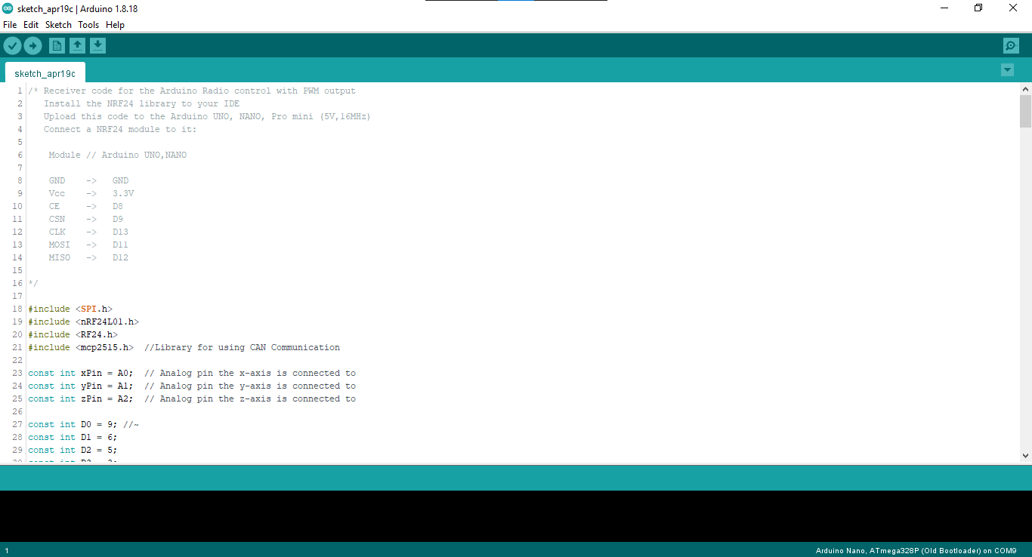 **Fig.5.1. Front Section Code**

**Fig.5.2. MCU Code**

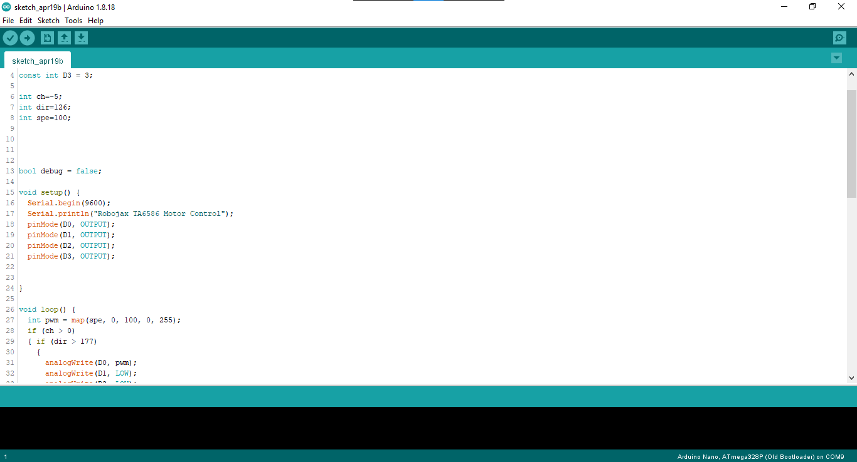

**Fig.5.3. Back Section Code**

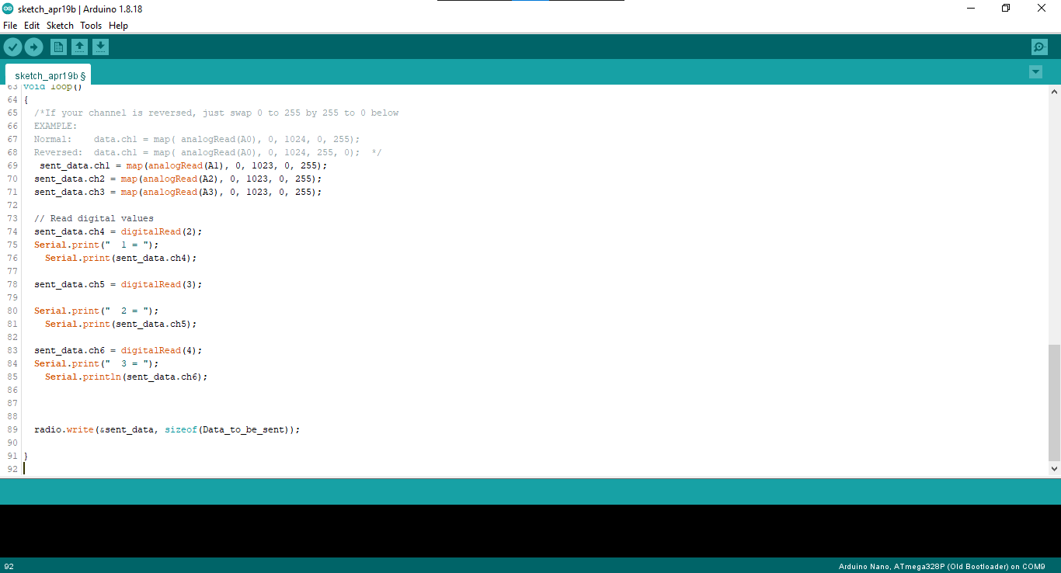

**Fig.5.4. Remote Code**

## FLOW CHART OF SYSTEM:

The adaptive headlight and emergency brake alert system consists of three separate flowcharts for each module they are as follows:

### Flow Chart of Front Section Module:

The Flowchart of front section module consists of design flow of detection of vehicle coming in front of vehicle.

### Algorithm:

1. Initialization
2. Light detected on sensor / object detected in front of car.
3. Detect the light source /direction of object.
4. Adjust the light beam accordingly.
5. Any signal coming from CAN master.
6. Adjust the light beam accordingly.
7. End

Fig.5.1.1 Flowchart of front section module helps to understand the steps which are required to perform the operation. It includes algorithm steps based on programming done in Embedded C in Arduino IDE software tool. This Flowchart steps can be useful for operations performed front section operation.

Start

Initialize the sensors

Transmit the data from B And Ultrasonic sensor to NANO

Direction upcoming light / object detected / data from Can

Data From CAN

Set LED light accordingly

End

**Fig 5.1.1 Flow Chart of Front Section Module**

### Flow chart for MCU:

The Flowchart of MCU consists of design flow of the system for tilt detection, control of car and CAN communication.

### Algorithm:

1. Initialization
2. Detect the data coming from NRF24.
3. Control the car.
4. Detect Speed, Break Intensity, and other control signal.
5. Process on It and transmit it to the can bus.
6. End

Start

End

Process on It and transmit it to the can bus.

Detect Speed, Break Intensity, and other control signal.

Control the car.

Detect the data coming from NRF24.

Initialize the sensors

**Fig.5.1.2 Flow Chart of MCU**

### Flow Chart of Front Section Module:

The Flowchart of back section consist of backlight, indicator and can interface.

### Algorithm:

1. Initialization
2. Detect the data coming from can bus.
3. Normal break / emergency break.
4. Flash the break light accordingly.
5. End.

End

Flash the break light accordingly.

Normal break / emergency break.

Detect the data coming from can bus.

Initialization

Start

**Fig.5.1.3 Flow Chart of Back Section**

The flowcharts detail the operation of three key modules within the system, each playing a vital role in ensuring the safety and functionality of the vehicle. The Front Section Module focuses on detecting obstacles or vehicles ahead by utilizing sensors and adjusting the headlights accordingly. This ensures optimal visibility for the driver while minimizing glare for oncoming traffic. The MCU, acting as the system's central control unit, receives commands from the remote controller via the NRF24 module, controls the car's movements, and processes data related to speed and brake intensity. It then communicates this information to the CAN bus for further coordination with other vehicle systems. Finally, the Back Section Module monitors data from the CAN bus, particularly signals related to braking actions, and adjusts the brake lights to signal normal or emergency braking to surrounding vehicles. This comprehensive approach to vehicle control and safety highlights the system's ability to adapt to changing road conditions and prioritize the well-being of both the driver and other road users.

**Summary-** The fifth chapter gives information related to programs used in the implemented system.

# CHAPTER 6 RESULTS AND FUTURE SCOPE

## RESULTS OF IMPLEMENTED SYSTEM:

The results of the implemented system tested for following Modules:

* + - Front vehicle detection.
    - Upcoming Vehicle detection.
    - Road curve detection.
    - Tilt detection
    - Emergency breaking and normal breaking detection.
    1. **Front Vehicle Detection:**

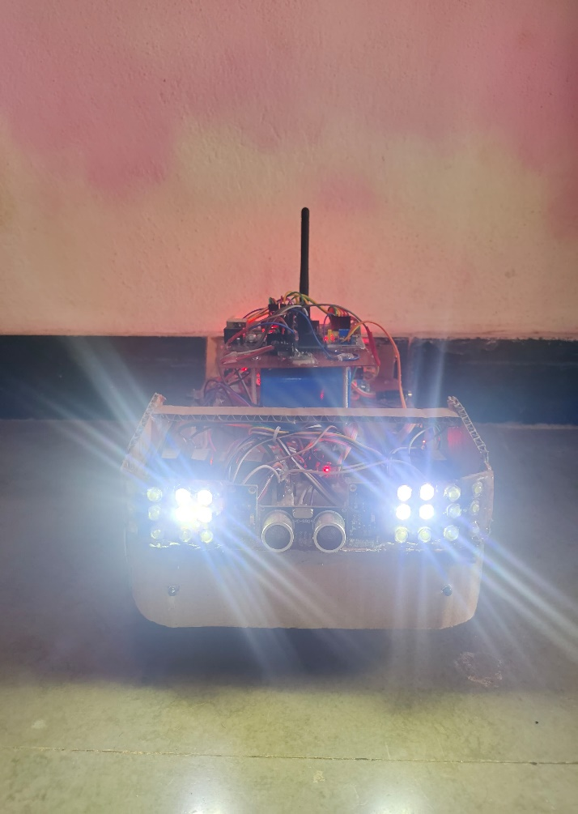The below Fig 6.1.1.1 shows the actual working of system, when a vehicle is detected in front of the car by the ultrasonic sensor, the response is twofold to mitigate glare and ensure safety. Firstly, the headlights automatically switch from high beam to lower beam to reduce glare for the approaching vehicle. This adjustment maintains visibility for the driver while minimizing discomfort for the oncoming driver. Secondly, the corner lights are activated to provide additional illumination around the periphery of the vehicle, enhancing visibility without causing additional glare.

**Fig 6.1.1.1 High Beam**

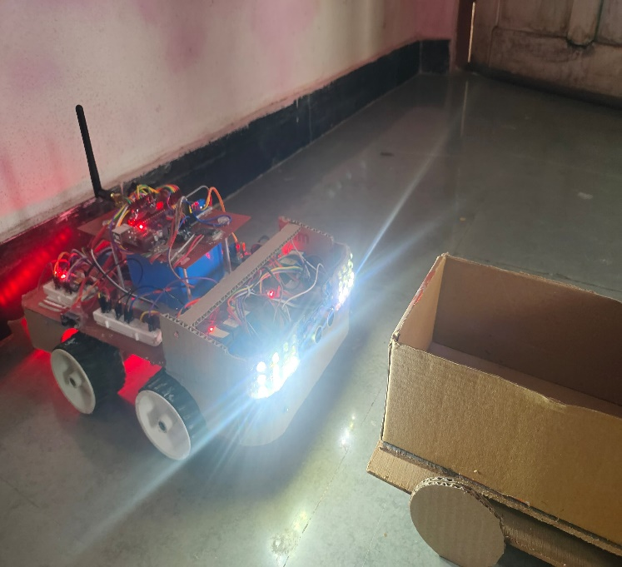In Figure 6.1.1.1, the LED represents the high beam state of the headlights, indicating maximum illumination for improved visibility. However, when a vehicle is detected in front of the car, as depicted in Figure 6.1.1.2, the system triggers a transition from high beam to low beam. This adjustment ensures that the headlights emit a less intense light, reducing glare for the approaching vehicle while still providing adequate illumination for the driver's visibility.

**Fig.6.1.1.2 Low Beam**

* + 1. **Upcoming Vehicle Detection:**

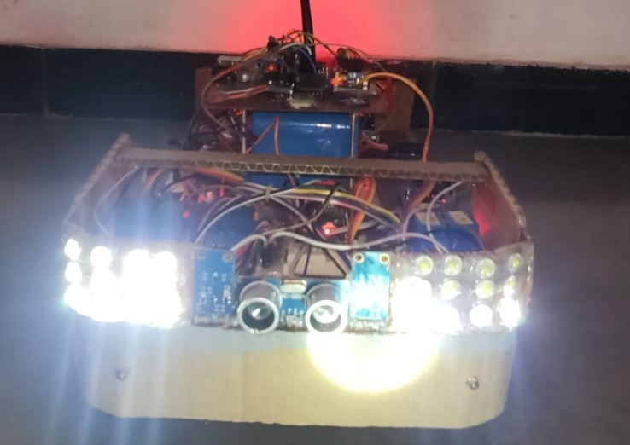In Figure 6.1.2.1, when an upcoming vehicle is detected on the left side, the left BH1750 sensor detects glare from the oncoming vehicle. Consequently, the high beam on the left side is turned off to prevent glare for the approaching vehicle, while the corner LEDs on the right side are activated to provide additional illumination for the driver's visibility.

**Fig.6.1.2.1 Vehicle on Left Side**

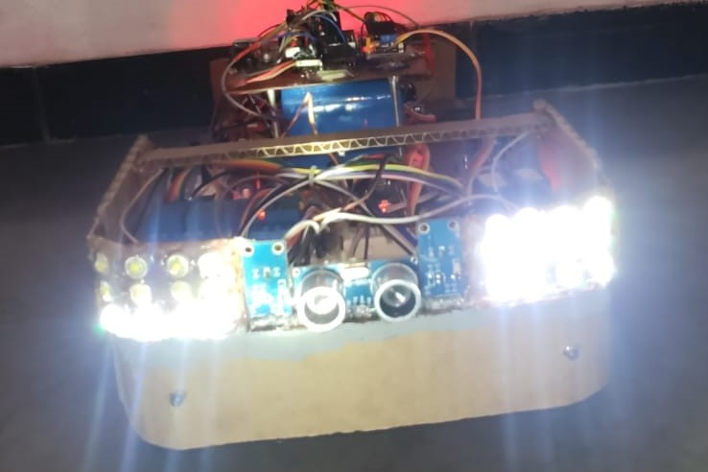Similarly, in Figure 6.1.2.2, when an upcoming vehicle is detected on the right side, the right BH1750 sensor detects glare, leading to the high beam on the right side being turned off. Simultaneously, the corner LEDs on the left side are turned on to enhance visibility for the driver.

**Fig.6.1.2.2 Vehicle on Right Side**

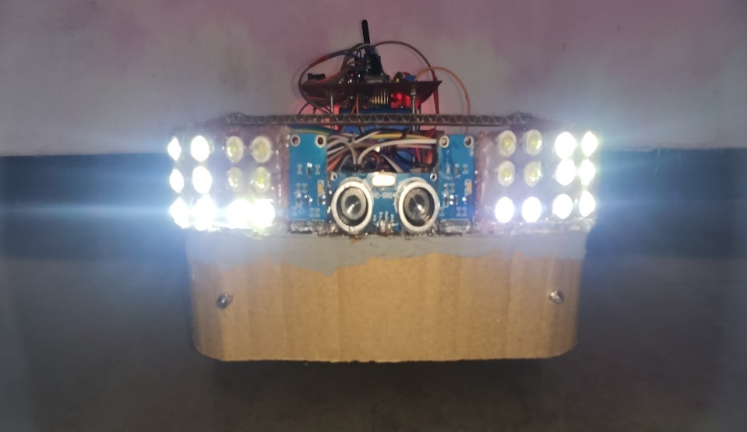In Figure 6.1.2.3, when an upcoming vehicle is directly in front, both BH1750 sensors detect glare. Consequently, both high beams are turned off to avoid causing glare for the oncoming vehicle. Instead, both sets of corner LEDs are activated to provide adequate illumination for the driver's visibility without causing discomfort to other road users. This adaptive approach ensures optimal lighting conditions based on the position of the oncoming vehicle, prioritizing safety and comfort for all drivers on the road.

**Fig.6.1.2.3 Vehicle in front of car**

* + 1. **Road Curve Detection.**

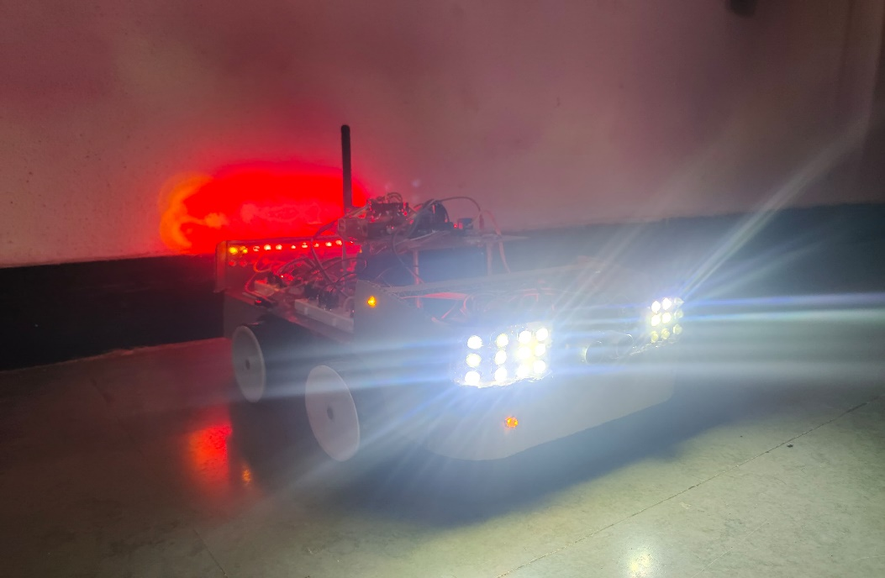In Figure 6.1.3.1, when the car is approaching a curve or preparing to turn, the system activates the corner lights on the side corresponding to the direction of the turn. This proactive lighting adjustment enhances visibility for the driver, illuminating the path ahead and indicating the intended direction of the turn to other road users. By activating the corner lights in anticipation of the turn, the system provides advanced warning and improves safety, especially in low-light conditions or when navigating unfamiliar roads. This adaptive lighting feature enhances the overall driving experience, ensuring smooth and confident maneuvering through curves and turns.

**Fig.6.1.3.1 Detection of Curve**

* + 1. **Tilt Detection**

In Figure 6.1.4.1, when the car experiences a tilt, such as when driving on a hill or uneven terrain, the ADXL335 sensor detects the tilt angle. This information is communicated to the front section module using the CAN protocol. Upon receiving the tilt data, the front section module adjusts the headlights accordingly to ensure optimal illumination of the road surface. By dynamically adapting the headlight angle based on the car's tilt, the system improves visibility and safety for the driver, especially in challenging driving conditions like hill areas. This adaptive lighting adjustment enhances the driver's confidence and comfort, allowing for smoother and safer navigation through varied terrain.

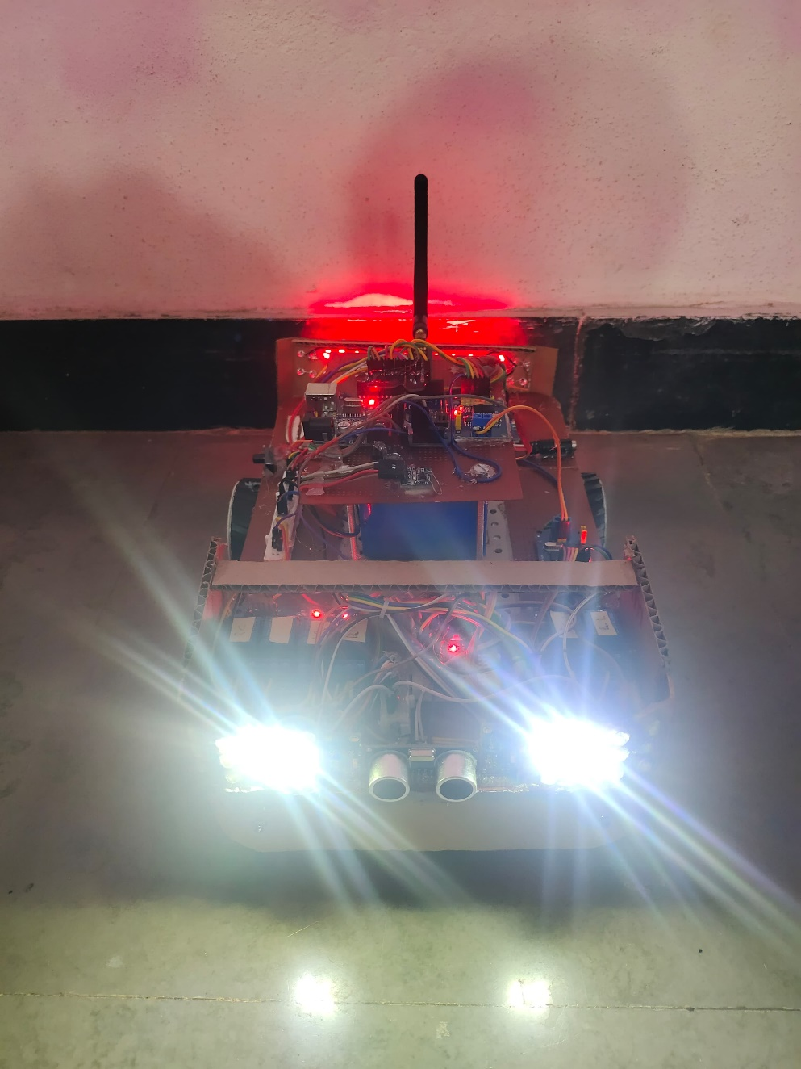

**Fig.6.1.4. Detection of Tilt**

* + 1. **Emergency Breaking and Normal Breaking Detection.**

In the system, the MCU is monitoring the car's speed and brake intensity to determine whether the braking action is normal or emergency. Based on this analysis, the MCU decides the appropriate response and sends corresponding data to the back section module. If the braking is determined to be normal, the MCU instructs the back section to turn on the LED lights in a standard manner to indicate regular braking to vehicles behind. However, if the braking is identified as an emergency, the MCU signals the back section to activate the LEDs in a specific pattern, such as blinking at a higher frequency, to alert surrounding vehicles of the sudden stop.

In Figure 6.1.5.1, representing normal braking, the backlight is activated in a standard manner, providing continuous illumination to indicate the deceleration of the vehicle. This steady backlighting serves as a conventional signal to vehicles behind, informing them of the car's reduced speed due to braking.

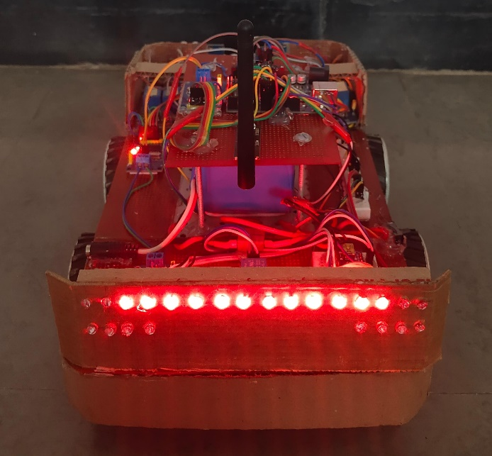

**Fig.6.1.5.1 Normal Breaking**

Conversely, in Figure 6.1.5.2, depicting emergency braking, the backlight LED blinks at a rate of 5Hz. This rapid blinking pattern is employed specifically during emergency braking situations to draw immediate attention from surrounding vehicles. The flashing backlight serves as a highly visible warning signal, alerting other drivers to the abrupt stop of the vehicle and helping to prevent rear-end collisions.

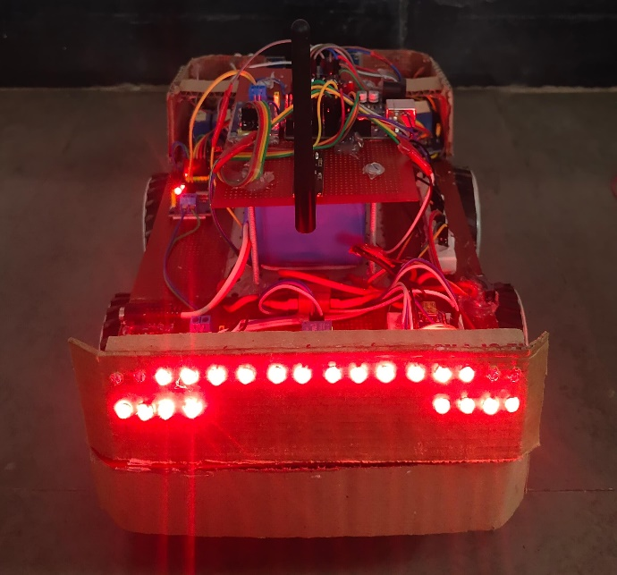

**Fig.6.1.5.2 Emergency Breaking**

* + 1. **Remote Controller**

The remote controller for the car is equipped with three joysticks and a two-way switch to provide comprehensive control over the vehicle's movement. The joysticks allow for precise manipulation of the car's direction and speed, with one joystick typically controlling forward/backward movement, another controlling left/right steering, and the third joystick potentially managing additional functionalities such as camera movement or auxiliary features. Additionally, the two-way switch provides a convenient means of toggling between different driving modes or activating specific functions, enhancing the versatility of the control system. The remote controller communicates wirelessly with the car's onboard system using NRF24 modules, ensuring reliable transmission of control signals for seamless operation. This setup offers intuitive and responsive control, enabling users to navigate the car with precision and ease.

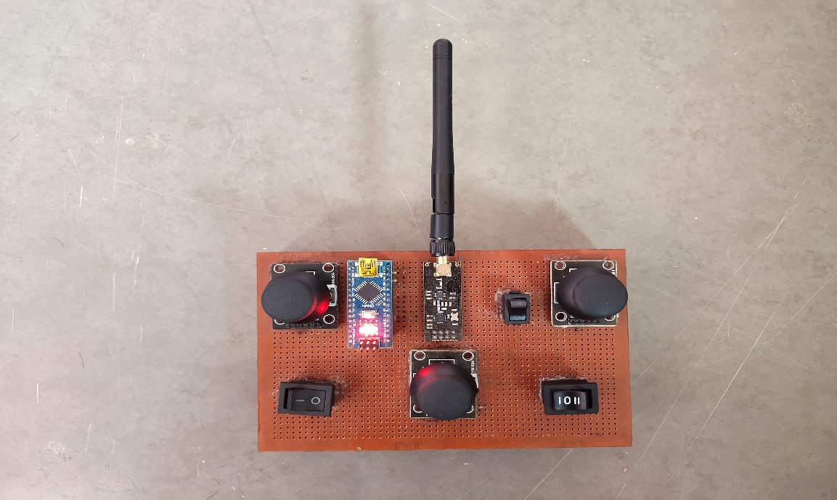

**Fig.6.1.6 Remote Controller**

## FUTURE SCOPE:

Automotive world is likely to observe promising and multifaceted developments about adaptive headlights and emergency brake alert systems in the future. Some of these possibilities are outlined below:

**Integration with Autonomous Driving:** As autonomous driving technology develops further; adaptive headlights and emergency brake alert systems would become de rigueur equipment. They will be seamlessly integrated with the rest of the autonomous driving system, thereby enhancing the level of safety and responsiveness in various driving scenarios.

**Sensor Fusion:** Future systems will incorporate advanced sensor fusion technology; it will complement the information obtained from cameras, LiDAR, and radar as well as other sensors to provide a holistic view of the vehicle's environment. This technology will support the detection of obstacles, pedestrians, and road conditions with better accuracy. In this case, adaptive headlight systems will predictively adjust in anticipation of curves and intersections and emergency brake alerts will have ample time to get drivers to react to potential collision risks in time.

**Predictive Analytics:** Using artificial intelligence and machine learning algorithms, future systems will be able to process vast amounts of data in order to predict potential hazards on the road. Thereby, predictive capabilities will allow adaptive headlights to proactively adjust in anticipation of hazards ahead and emergency braking alerts to warn drivers about potential collision risks much before time.

**Communication with Infrastructure and Other Vehicles:** As vehicle-to-everything (V2X) communication technology becomes more widespread, adaptive headlights and emergency brake alert systems will be able to share real-time data with roadside infrastructure and other vehicles. The information that will percolate from the roadside infrastructure and other vehicles will support even more precise adaptive lighting and proactive braking interventions.

**Personalized Settings and Preferences:** Future systems will offer personalized settings and preferences tailored to individual drivers. Drivers will be able to adjust parameters such as headlight brightness, beam pattern, and emergency brake sensitivity to their driving style and preferences while being comfortably and safely driven on the road.

**Augmented Reality Head-Up Displays:** Augmented reality HUDs will direct relevant information into the driver's field of view, such as adaptive headlight status, emergency brake, and navigation instructions. This seamless presentation of critical information will be effective in situational awareness and minimize driver distraction, which will otherwise improve overall safety.

**Energy Efficiency and Sustainability:** The future adaptive headlight systems will use energy-efficient LED or laser light sources along with advanced optical designs that will consume minimal power, provided optimal lighting performance. This will extend the range of electric vehicles, contributing even more to sustainability through reduced energy consumption and carbon emissions.

In a nutshell, the future of adaptive headlights and emergency brake alert systems is one of integration, intelligence, and innovation in shaping the future of automotive transportation, emphasizing the enhancement of safety, comfort, and efficiency on the road. With the ever-advancing technologies, these systems will play an increasingly important role in the conception of the future of automotive transportation.

## ADVANTAGES:

There are several advantages of Adaptive headlight and emergency brake alert system. Here are some of them:

* Safe Night Driving
* Drivers Convenience
* Enhanced Safety
* Energy Efficiency
* Reduces Rear End Collisions

## DISADVANTAGES:

* Initial Investment Cost
* Technical Expertise Required
* Connectivity Issues

**Summary-** The sixth chapter gives the overall results of the implemented system along with that future scope, advantages and disadvantages of implemented system.

# CHAPTER 7

## 7.1 CONCLUSION

In summary, our adaptation to the development of our adaptive headlight and emergency brake alert system takes a stride toward automobile safety technology, especially under nighttime driving conditions. By successfully combination of front and upcoming vehicle detection, road curve detection, tilt detection, and differentiating emergency from normal braking, we have constructed a strong suit of safety equipped to mitigate risks and build confidence among drivers. Such a system not only increases visibility under challenging conditions but also gives proactive alerts and interventions toward the prevention of accidents before they occur. Moving ahead, our commitment to ongoing innovation and fine-tuning guarantees that drivers traverse the roads with more peace of mind in the sense that their adaptive technology is working round the clock to keep them safe.

In other words, our adaptive headlight and emergency brake alert system is a perfect concoction of high-end sensor technology and intelligent algorithms designed to handle the intricacies of nighttime driving. By putting together high-quality detectors with rapid response mechanisms, we crafted a solution that not only increases safety but also places a new mark for the future of automobile innovation. Looking ahead, we are satisfied with the way technology evolves, as we put together industries toward making roads safer for all.

**Summary-** The seventh chapter gives the conclusive part of the system.

# REFERENCES

## RESEARCH PAPERS

1. Linfeng Jia **“Design of a Smart Lighting System Based on Sensor Integration and Automation”**, Vol. 1 No. 5 : Issue 5, Dean&Francis (2024).
2. Jiang Li. ***“A Matrix Headlamp Design Based on Artificial Intelligence Controller Control”,*** Journal of Physics: Conference Series, ICCASIT 2020
3. Keshav H. Jatakar, Gopal Mulgund, A D. Patange, B B. Deshmukh, **“Vibration monitoring System based on ADXL335 accelerometer and Arduino Mega2560 interface”**, JOURNAL OF ALGEBRAIC STATISTICS Volume 13, No. 2, p. 2291-2301 ISSN: 1309-3452,2022.
4. Leo Louis **“Working principle of Arduino and using it as a tool for study and research”** International Journal of Control, Automation, Communication and Systems (IJCACS), Vol.1, No.2, April (2016).
5. Pallavi Polsani et al. “**Design & Verification of Serial Peripheral Interface (SPI) Protocol”**, International Journal of Recent Technology and Engineering (IJRTE) ISSN: 2277-3878 (Online), Volume-8 Issue-6, March 2020
6. Dr. Sagar Patel, Prachi Talati, Saniya Gandhi, “**Design of I2C Protocol”**, International Journal of Technical Innovation in Modern Engineering & Science (IJTIMES) Volume 5, Issue 03, March-2019.
7. Kristian Ismail. **“Design of CAN bus for research applications purpose hybrid electric vehicle using ARM microcontroller”,** 2nd International Conference on Sustainable Energy Engineering and Application, ICSEEA 2014.
8. H Shambhavi, Dr. Devraju R **“AUTOMIZING CAN COMMUNICATION SYSTEM USING RASPBERRY-PI”** International Research Journal of Modernization in Engineering Technology and Science Volume:04/Issue:09/September-2022.
9. Dzulfiqar Dwi Yanto et al “**Design of Automatic Headlight Based on Road Contour and Other Headlight Light**” Conference: 2020 2nd International Conference on Industrial Electrical and Electronics (ICIEE) October 2020.
10. Arpita K et al “**Automated Headlight Intensity Control and Obstacle Alerting System**” ternational Journal of Engineering Research & Technology (IJERT) ISSN: 2278-0181 Published by, www.ijert.org NCESC - 2018 Conference Proceedings Special Issue – 2018.
11. Surej Mouli et al “**Investigating the Cognitive Response of Brake Lights in Initiating Braking Action Using EEG”** IEEE TRANSACTIONS ON INTELLIGENT TRANSPORTATION SYSTEMS, VOL. 23, NO. 8, AUGUST 2022.
12. Mohammad Sadegh Sohrabi **“Effects of Flashing Brake Lights on Drivers’ Brake Reaction Time and Releasing Accelerator Gas Pedal Time”** Health in Emergencies and Disasters Quarterly. 2019.
13. Ms. Aishwarya J. et al **“Adaptive Headlight System for Automobiles”** International Journal of Engineering Research & Technology (IJERT) ISSN: 2278-0181 [2020].
14. JESSE PIRHONEN **“Predictive Braking with Brake Light Detection—Field Test”** IEEE assess Digital Object Identifier 10.1109/ACCESS.2022.3173416 May 9, 2022.
15. Kirthanaa Raghuraman et al **“Adaptive Headlight System for Accident Prevention”** 2019 International Conference on Recent Trends in Information Technology. 11 March 2019.
16. T. E Arijaje et al **“Design and Construction of LED Matrix Display”** OP Conference Series: Earth and Environmental Science l 2018 IOP Conf. Ser.: Earth Environ. Sci. 173 012007 [2018].
17. Min-Chih Hsieh et al **“A Simulation-Based Study of the Effect of Brake Light Flashing Frequency on Driver Brake Behavior from the Perspective of Response Time”** Behav. Sci. 2022, 12, 332. https://doi.org/ 10.3390/bs12090332. 14 September 2022.
18. Hani Almimi, Ali Al Dahoud, Mohamed Fezari, Mohammad Sh, **“A Study on New Arduino NANO Board for WSN and IoT Applications”** Article in International Journal of Advanced Science and Technology · October 2020.
19. Alessio Carullo, Marco Parvis **“An ultrasonic sensor for distance measurement in automotive applications”** Article  in  IEEE Sensors Journal · September 2001.
20. Mobasshir Mahbub **“Design and Implementation of Multipurpose Radio Controller Unit Using nRF24L01 Wireless Transceiver Module and Arduino as MCU”** Article  in  International Journal of Digital Information and Wireless Communications · September 2019.

## WEBSITES

* 1. [**https://www.arduino.cc/**](https://www.arduino.cc/)
  2. [**https://www.mouser.com/datasheet/2/348/bh1750fvi-e-186247.pdf**](https://www.mouser.com/datasheet/2/348/bh1750fvi-e-186247.pdf)
  3. [**https://www.audi.in/in/web/en.html**](https://www.audi.in/in/web/en.html)
  4. [**https://www.electronicscomp.com/**](https://www.electronicscomp.com/)
  5. [**https://robu.in/**](https://robu.in/)
  6. [**https://www.researchgate.net/**](https://www.researchgate.net/)[**https://ieeexplore.ieee.org/Xplore/home.jsp**](https://ieeexplore.ieee.org/Xplore/home.jsp)

# APPENDIX

**Appendix-A Project Competition Participation**

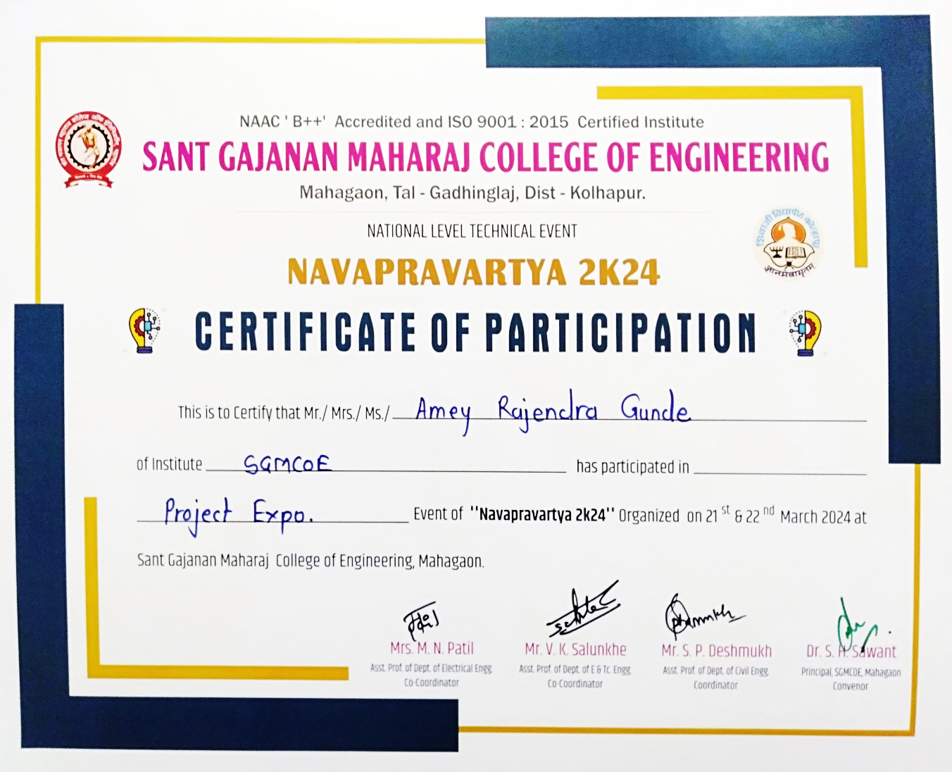

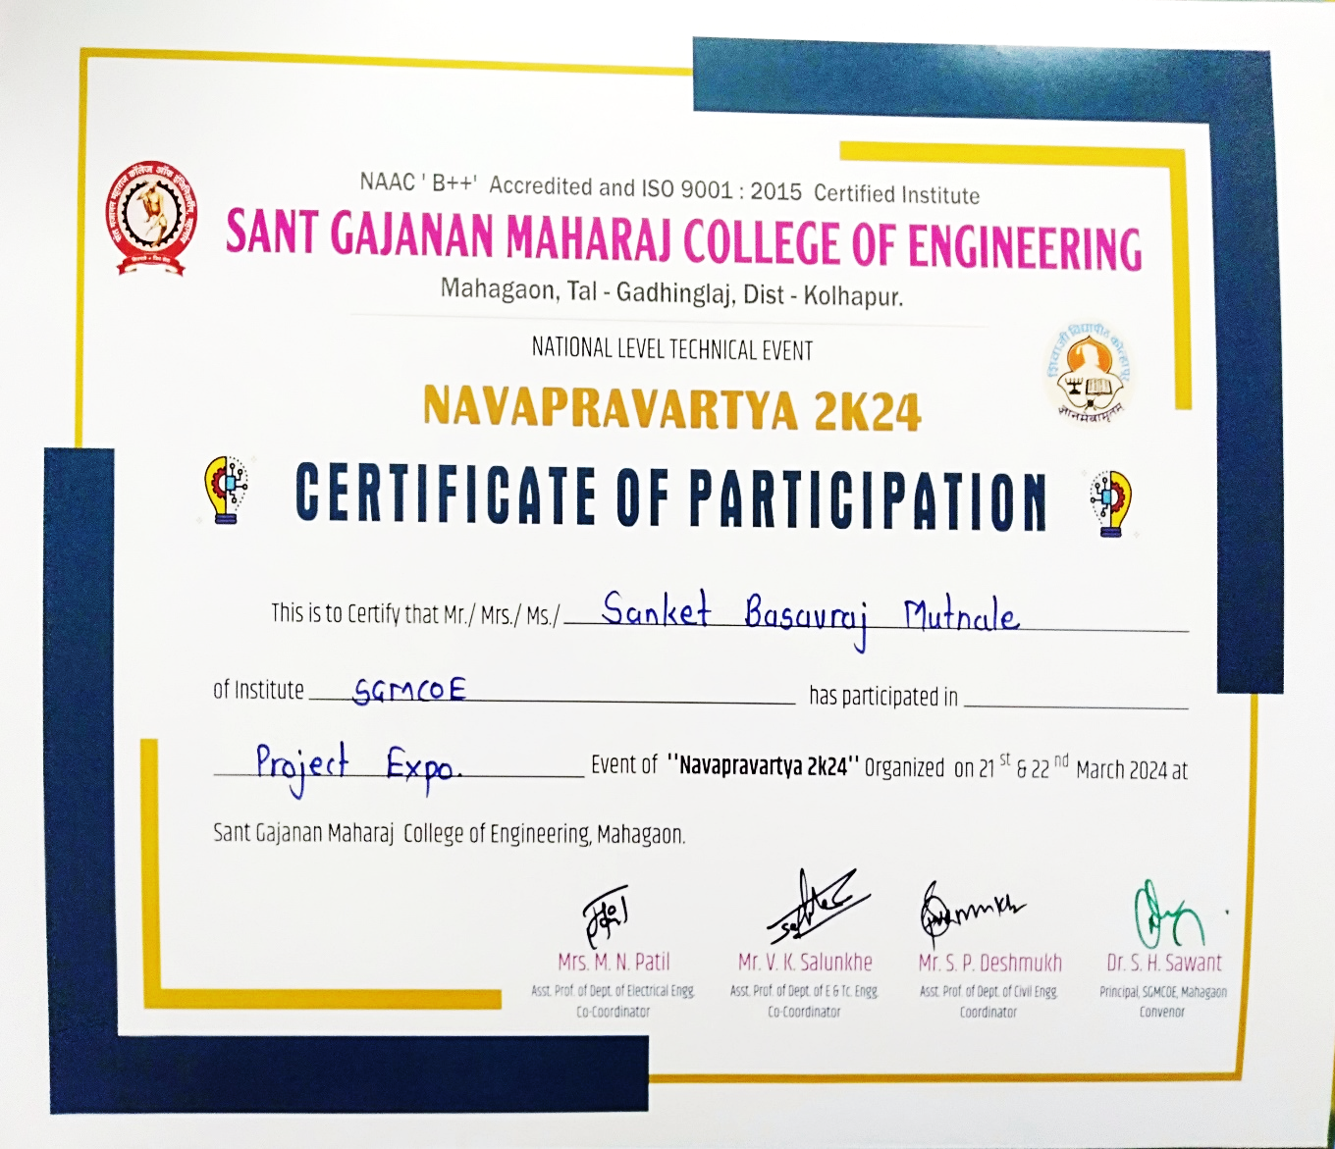

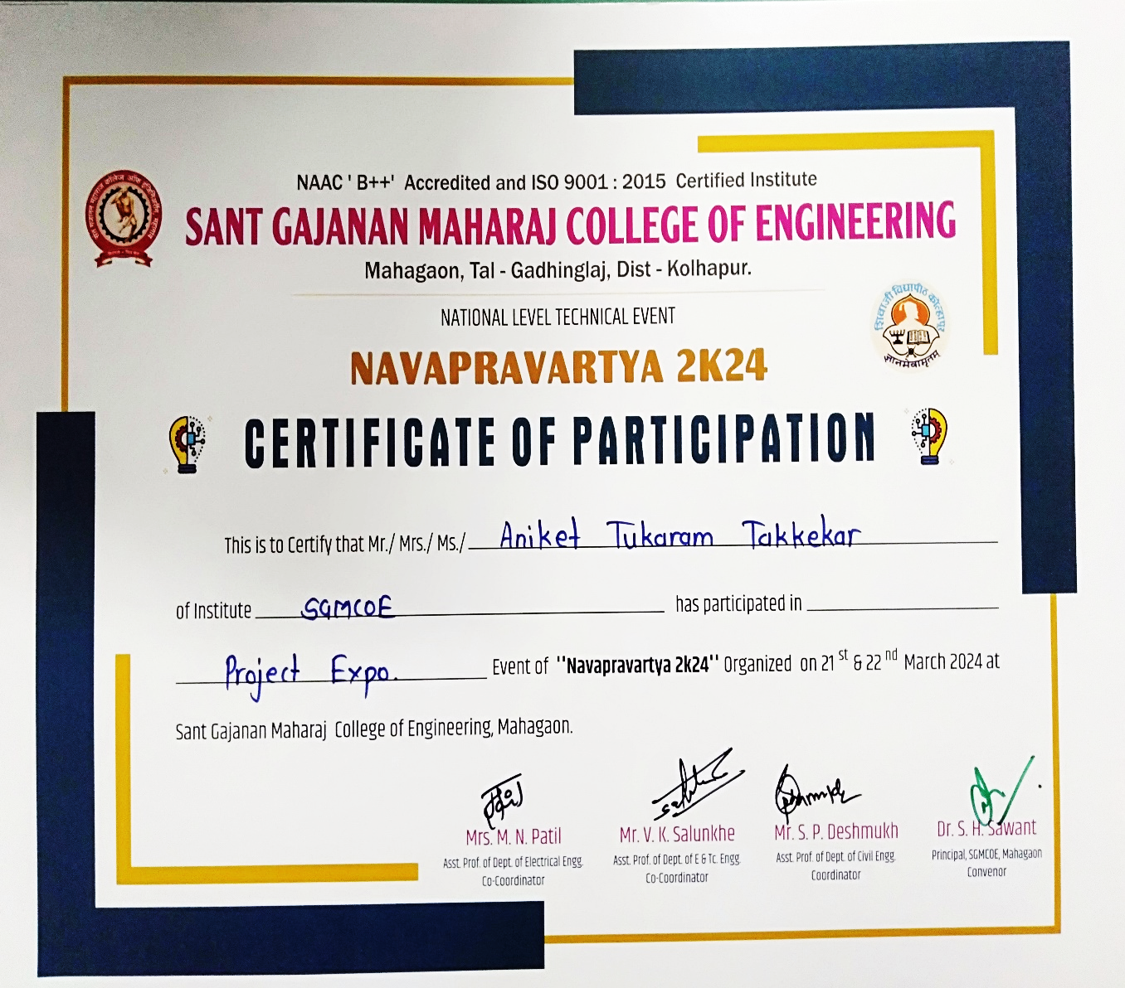

**Appendix-B Research paper published/Acceptance**



